Leading Players Through Levels

There are a few ways that this can be done, some are rather simple, others are more complex. The more complex methods may incur some additional development time and effort; therefore, a simpler solution is more likely to be the ideal solution.

A simple solution, which shouldn’t take a huge amount of time to implement, would be to number every factory we have. This would replace the current text above each factory, which we have discussed removing previously. A huge amount of games, in our genre and outside of it, use this in the form of a level select screen, which is basically how our overworld functions. An example of this can be seen below.

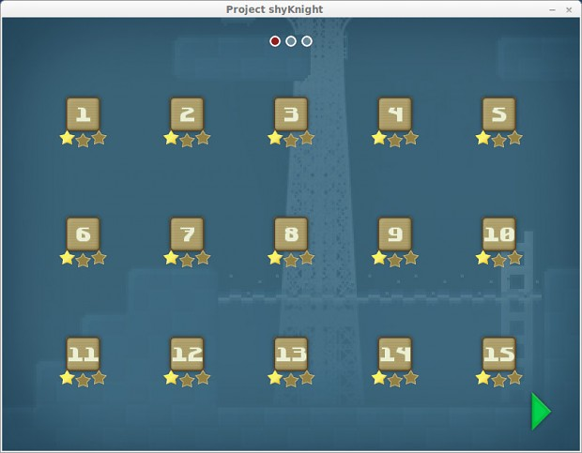

This is very simple but can convey the information we need it to, in an effective way. Some artwork may need to be produced for this, but it can be just text in our chosen font, for the sake of consistency.

Another, more complex way to lead players through levels, is to lock off levels, either by only lighting individual levels in each section, or by combining with the previous idea and putting a padlock icon over the number above each factory. This would allow players to see how many factories they have left to unlock in each section, whilst only allowing them to access certain ones. These levels should be automatically unlocked however, as the player already has to manually unlock sections, so this could lead to confusion. This can also act as a reward to the player, as they can immediately see that they’ve gained something for completing a level. This acts as a form of instant gratification to the player, thus acting as a possible hook, to keep the player invested.

This method would be my preferred way of leading the player, therefore, below is a quick concept of how I imagine it looking in game:

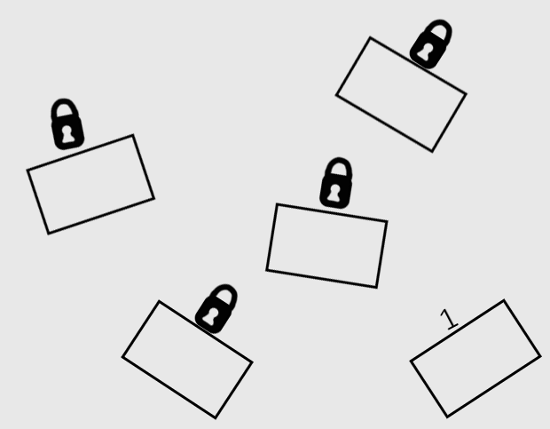

A version of this will be uploaded to the repo, so it can be viewed in more detail.